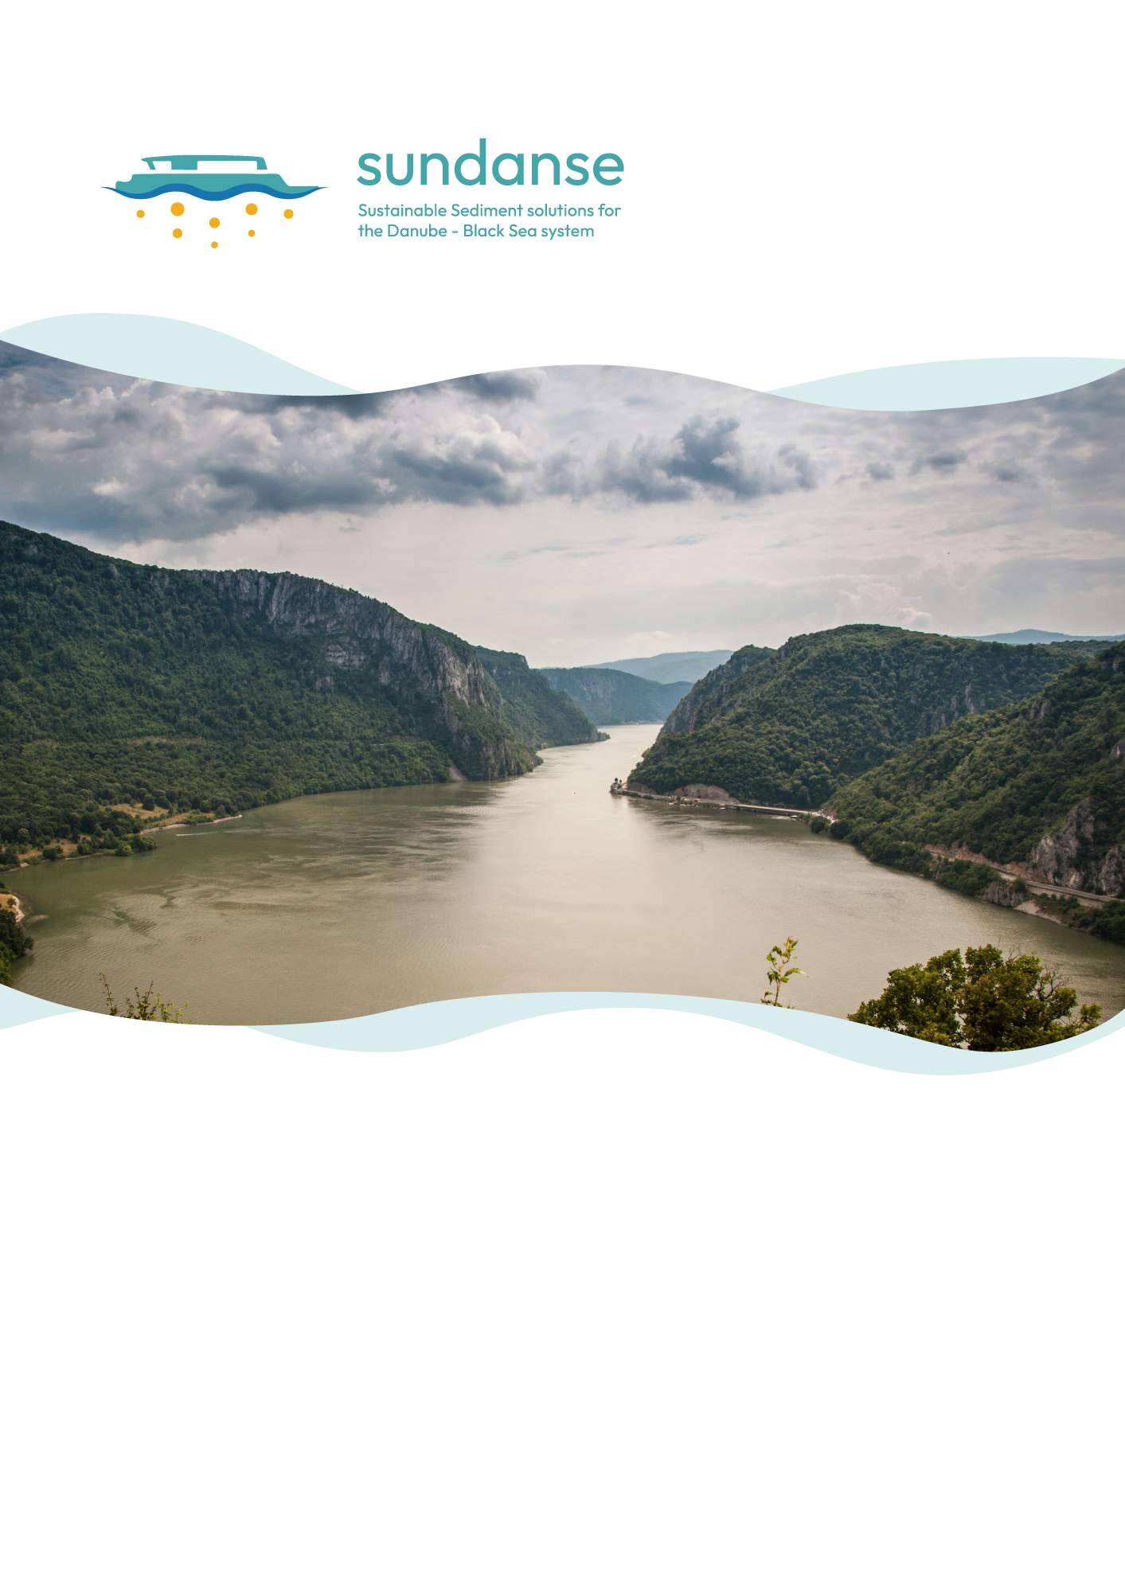
SUNDANSE Open Call #2 – Freshwater Ecosystems Call
Annex 2 – Replication Activities Catalogue

Catalogue of Replication Activities, Technologies and Services
Your proposal for this Open Call must be directly focused on the deployment, testing, and engagement of the developed SUNDANSE solutions within a new region.

To be eligible, your project must specifically address at least one of the following core thematic areas related to sediment dynamics and river health:

For the purposes of this Open Call, eligible water bodies include rivers and the following additional systems: anthropogenic systems (canal, reservoir, settling basin/tailings pond); transitional and coastal systems (river delta, estuary, coastal lagoon, tidal flat); lentic systems (open lake, closed lake, oxbow lake); and lotic systems (stream/creek, fluvial lake).

Proposals may also include testing of the SUNDANSE Toxicity Analyser being developed by the Israeli academic partner. This optional technology supports rapid toxicity screening of sediment-related samples to help identify ecotoxicological risks and complement broader sediment quality assessment activities. Applicants wishing to include this option should describe it clearly in the proposal, including the intended use, expected value for the target site, and any required support.

- Flow monitoring
- Sediment quantity monitoring
- Sediment quality assessment (including the identification of pollution sources of the river(s))
- Actions to improve awareness raising on sediment flow alterations

Core activities (Mandatory for all applicants)
Every funded project must implement the following activities:
- Stakeholder engagement and environmental awareness campaigns – engage local stakeholders to discuss results and co-design future measures.
  - Each project should organise at least one workshop (online or on-site) or multi-actor meeting. Awareness campaigns on sediment management challenges and solutions should also be conducted.
  - Activities include facilitation, dissemination, and collection of stakeholder feedback for future measures. SUNDANSE will provide templates, materials, and facilitation guidance. Participation lists and reports must be included as deliverables.
- Strategic action plan and implementation roadmap – prepare a regional plan for replication and scaling of sediment solutions.
  - Development of a strategic document outlining actions for sustainable sediment management and potential scaling of SUNDANSE solutions. The roadmap includes priorities, responsible institutions, indicative budgets, and timelines.
  - Applicants must prepare a Regional Action Plan. The document summarises the findings from proposed activities and outlines proposed next steps for implementation.
- Replication activities (Table 1) – each project is required to replicate at least one activity from the list provided in Table 1. Applicants may choose the activity or combination of activities that best fit their context and objectives, within the available €100,000 budget. While not all listed activities are expected to be replicated, projects are encouraged to implement as many as feasible within their proposed plan and resources.

Services provided by SUNDANSE
Applicants may also benefit from project services, depending on their proposed activity (the mentoring will be up to 8h per month per funded Associated region):
- Consultancy on methods for laboratory analysis of sediment samples to test for the presence of contaminants, microplastics, organic micropollutants, and toxic metals.
- Guidance on sampling and preservation methods.
- Guidance for Data harmonisation & QA/QC – ensuring results meet FAIR standards.
- Guidance for Modelling – consortium experts assist with simulation runs or setup a modelling plan strategy.
- Stakeholder engagement support – facilitation guidelines, templates for workshops.
- Policy & governance guidance – frameworks for regulatory analysis and roadmap preparation.

Expected outputs & deliverables
Each project must deliver:
- Stakeholder engagement outputs (workshop report, participant lists, outcomes).
- Regional Action Plan & Roadmap (aligned with SUNDANSE framework).
- Within the replication activities a project chooses (see Table 1), it is expected to propose measurable outcomes which should be indicated in the technical proposal and project plan.

Data sharing options
Applicants must indicate willingness to share project data:
- Yes - Open - dataset openly accessible via SUNDANSE Data Network.
- Yes - Restricted - dataset catalogued but access subject to conditions.

Replication
The Open Call invites new regions to replicate the project’s pilot activities. Selected applicants will test and adapt to specific sediment monitoring, management, and/or prediction solutions to their regional context. Technical proposals must specify which aspects will be addressed and explain how the proposed activities will contribute to demonstrating the transferability of project results and developing best practices for sustainable sediment management.
Table 1: Replication Activities Overview
Reference | Replication Activity name | Replication description | Use Case
A1 | Baseline assessment of the target area | A documentation can be prepared regarding the data, methods, and procedures used locally that are not included in public databases, such as sediment measurements, erosion observations, and the potential impact of agricultural activities (e.g., aerial imagery), etc. The review will ensure a harmonized baseline knowledge, creating comparability with the original case and enabling informed decision-making in replication areas. | All
A2 | Flow monitoring | This activity involves the hydrological monitoring of flow regimes, discharge, and/or velocity. It can be replicated in any partner region with flowing waters by applying methodologies and procedures similar to those used in SUNDANSE to measure the monitored parameters. Such replication will ensure the generation of comparable datasets across sites, facilitating regional and EU-wide assessments. | All
A3 | Mapping the target area | Remote sensing, GIS tools, and open-access datasets can be used to fully replicate this activity. By applying harmonized geospatial standards and performing comparative analyses of land use, hydrology, and pollution drivers across regions, the transferability of results can be greatly enhanced. | All
A4 | Sediment quantity monitoring | This activity can be replicated using consistent sampling protocols (e.g., depth-integrated samplers, turbidity sensors), ensuring strong cross-site comparability. It provides essential input for assessing sediment balance in associated regions by applying methodologies and procedures similar to those used in SUNDANSE to measure the monitored parameters. | All
A5 | Granulometric characterization of suspended and/or benthic sediments | Laboratory sieves, laser diffraction, and/or frequency methods can be used for particle size distribution analysis by applying methodologies and procedures similar to those used in SUNDANSE for monitoring the same parameters. Replication of this activity guarantees consistent data across the targeted regions, supporting sediment transport modelling and ecological risk assessments. | All
A6 | Microplastic contamination assessment in suspended and/or benthic sediments | This activity can be replicated following the extraction and identification techniques and protocols used in the project (e.g., density separation, µFT-IR spectroscopy analysis, etc.) by applying methodologies and procedures similar to those used in SUNDANSE for monitoring the same parameters. Obtained results can provide important information about pollution profiles of the targeted region and ensure a cross-regional benchmarking. | All
A7 | Analysis of microorganic pollutants (PAHs, PCBs, pesticides, tire additives) in sediment samples | Replication relies on established analytical protocols developed during the project using the GC-MS technique and methods by applying methodologies and procedures similar to those used in SUNDANSE for monitoring the same parameters. This approach will allow determination of the contaminant profiles for the targeted region, highlighting local pollution pressures and transferability of mitigation measures. | All
A8 | Toxic metal contamination assessment in sediment samples (Pb, Cu, Cd, Zn, etc.) | This activity is reproducible by using standard digestion and ICP-MS and/or XRF techniques by applying methodologies and procedures similar to those used in SUNDANSE for monitoring the same parameters. The results obtained will ensure cross-site comparability and will enable regional mapping of metal pollution hotspots and support risk-based management. | ALL
A9 | Toxicity evaluation of suspended sediment samples | This replication activity enables a harmonized evaluation of ecotoxicological risks across diverse ecosystems. The use of standardized bioassays (e.g., luminescent bacteria, benthic invertebrates) ensures that SUNDANSE-related activities in associated regions are reproducible and comparable, following methodologies and procedures similar to those applied in SUNDANSE for monitoring the same parameters. | ALL
A10 | Numerical modelling of sediment transport dynamics | Hydrodynamic and sediment transport models can be developed to assess erosion-sedimentation patterns and morphological changes on critical sites for navigation along the river from the targeted region using open-source software package such us open TELEMAC. The replication activity yields the development of a similar sediment transport model such as the ones developed within the project. These models should be applied to test the effectiveness of sediment management solutions. | All
A11 | Development of normative frameworks for real-time data utilization in pollution management | Replication of the activity involves designing governance models and digital tools for data collection, sharing, and decision support with local and regional stakeholders and decision-makers. Standardization across regions enhances interoperability, ensuring that real-time data supports effective transboundary pollution management. | All
A12 | Assessment of inland waterway transport impact on sediment dynamics | Hydro morphological surveys and AIS traffic data integration are replicable methodologies that can be used for targeted regions. This will highlight trade-offs between navigation, ecology, and sediment management. | Romania

